UNPICKING THE MEANING OF THE DECEPTIVE MATHEMATICS BEHIND THE COVID ALERT LEVELS
Paul Ernest
University of Exeter
p.ernest@ex.ac.uk
Thomas Woolley (2020) has written an interesting piece explaining why the mathematics behind the Covid alert levels makes no sense. He critiques the government’s ‘mathematical’ models of Corona Virus. This was broadcast on British national television on 10 May 2020 (Johnson 2020). Woolley shows problems with the 3 slides used to model the dangers of Covid-19, and the UK Government’s response to it. Here I extend his critique.
Mathematical Critique
In one of the slides (Fig. 1) there is a central equation, Covid Alert Level = R (Rate of infection) + Number of infections. In brief: CAL = R + N.
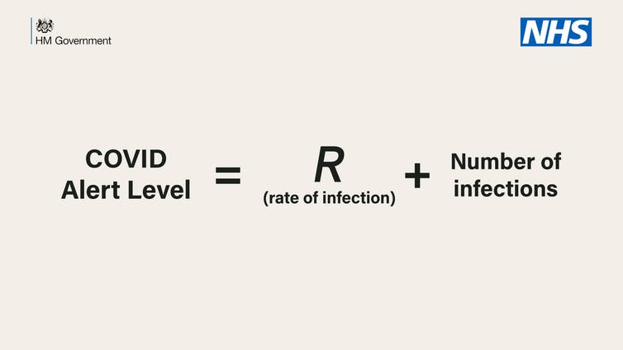
Figure 1: UK Government slide showing equation underlying their response to Covid-19
As Thomas Woolley correctly points out, the units on the left hand side (LHS) and the right hand side (RHS) of this equation do not match up. The Covid Alert Level (CAL) is a discrete number in the range 1 to 5, so it is a non-parametric statistic (See figure 2). These are just numbers to designate sequential steps. Step 4 is not twice as bad as step 2, for no quantitative relationship exists between them. They could just as easily be named A to E, for it is only their ordering that matters.

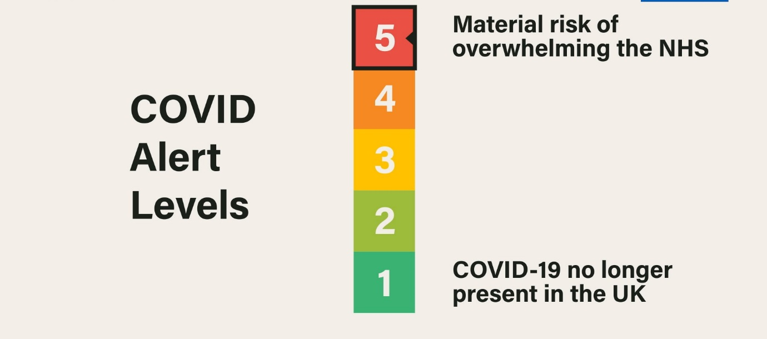
Figure 2: UK Government slide showing Covid Alert Levels
Returning to the equation, whatever R + N may be, it is not of the same kind as the CAL, being a single numerical quantity, mostly made up of a number of persons (currently a large number), and unlikely to be a whole number (unless R happens to take an integer value), and certainly not restricted to whole numbers in the range 1 to 5. So, the equation is incoherent.
But there is a deeper problem and misunderstanding in this equation, not brought out explicitly by Woolley. (This is not to criticise him, but to add a further critical emphasis). The term R is the Rate of infection of the disease. If R = 1.5, then every infected person spreads it to 1.5 people on average, and the diseased population keeps growing. If R = 0.5, then the diseased population starts to shrink. But rates are fundamentally multiplicative terms, so if the RHS of the equation was RxN it would mean something, even if not mathematically linked to the LHS. Illustrating this with some numbers, one can say that if 100,000 people are infected (N = 100,000), and R = 1.5 (or 0.5) then RxN = 150,000 (or 50,000, respectively), meaning that 100,000 people each infect 1.5 (or 0.5 persons) on average, thus each leading to 150,000 (or 50,000) new cases of infection. Using these same sample values (R = 1.5 or 0.5), the value of R + N is about that of N (100,001.5 or 100,000.5, respectively). Thus, in the formulation proposed by the government, when N is large, as it is at present, R has negligible effect on the overall sum R+N and hence next to no effect on CAL. But we know this is untrue. The rate of spread is the key to the whole pandemic.
To misunderstand rates as additive rather than multiplicative is an elementary error widely noted among young children who have not made the developmental step to what is known as the Formal Operational Stage of thinking (comprising abstract logical reasoning), in the terms of Piaget’s theory. This error is particularly alarming in this context, coming as it does with the full authority of HM Government and NHS.
The misleading use of mathematics to back up the presentation of the Governments Covid Strategy was termed “number theatre” by David Spiegelhalter (as Anjana Ahuja 2020 reports). But my point here is not a political one. Rather it is simply to point out the worrying fact that no one in No. 10 (the Prime Minister’s office) spotted the errors, or if they did, did not care about their inaccuracy. For it is well within the grasp of an ordinary school child to identify the errors and absurdities in the presentation.
As a side issue I note that this context provides those of us in education with an opportunity that can be used in teaching mathematics. The concept of R, the rate of spread of the infection, indeed presents a useful concrete example of ratio and proportion which can be exploited in the teaching of these ideas. As a hot and current issue, it adds relevance to the mathematics curriculum (unless the recency of tragedy makes it an unwelcome reminder).
Political Critique
However, the erroneous presentation also provides political commentators and opponents, and indeed those simply wanting to keep the government honest, with an opportunity to make a political point, that is to show up the shallowness of the government's plans and policies.
In trying to make sense of the deceptive equation I can only suppose that it is a metaphoric, and hence non-mathematical rendering of a sentence like "We will determine the C Alert Level by making judgements based on the Rate of growth AND (this is where the + sneaks in) the Number infected". But it is just Number Theatre to pretend that the science forces this judgement on the government and through a law expressed as an equation.
The only conclusion I can reach is that this piece of Number Theatre is purely a smokescreen designed to blind the ‘common man or woman’ with science, by giving a spurious sense of mathematical precision and scientific authority. The government has chosen to follow only the most politically expedient scientific advice, leading to the highest death toll in Europe, in both absolute and comparative terms, as well as in all places further East, at the time of writing.
Through the use of the equation, the government is implying that their actions are the necessary consequences of following scientific advice. In so doing, the government is shifting the responsibility onto the scientists. But the courses of action were actively and consciously chosen by the government from the wide range of possible strategies open to them. No strategy was forced on them, and it is on the public record that a great deal of advice that could possibly have saved tens of thousands of UK citizen’s lives was disregarded and rejected. To see such advice, one only has to look at World Health Organisation (2020), published on 12 February 2020, or the British Medical Journal (2020), published on 30 March 2020. Put simply, the WHO advice was Test, Trace, Isolate, as well as ensuring that everybody professionally involved with the pandemic had personal protection equipment.
This example provides those of us in critical mathematics education with an opportunity that can be used in teaching critical mathematics. The use of an unsound mathematical equation as a tool for persuasion and blame-shifting presents a very useful concrete example of mathematics as a political weapon. The visible Number Theatre conceals the decisions and interests that underpin a government’s political choice of strategy, whatever those might be. A critical mathematics education aims to equip all school leavers and adults with the mathematical skills to understand and critique slanted, deceptive and spurious uses of mathematics by corporations, advertisers, the media, government and other interest groups and lobbyists, irrespective of whether they lean politically to the right or the left. Such an empowered citizenry is a necessary component of any democratic society. It is an essential bulwark to safeguard our widely shared values of truth, freedom and mutual care, as well as democracy itself.

22 May 2020

References
Ahuja, Anjana (2020) Boris Johnson’s Covid-19 threat alert system is a parody of mathematical precision, New Statesman online, at https://www.newstatesman.com/science-tech/coronavirus/2020/05/boris-johnson-s-covid-19-threat-alert-system-parody-mathematical. Accessed 16 May 2020.
British Medical Journal (2020) Covid-19: why is the UK government ignoring WHO’s advice? BMJ 2020; 368 doi: https://doi.org/10.1136/bmj.m1284 (Published 30 March 2020) Cite this as: BMJ 2020;368:m1284. Accessed 22 May 2020.
Johnson, Boris (2020) UK Prime Minister’s broadcast on British national TV on 10 May 2020 about the Covid-19 virus threat and the UK Government response. https://www.youtube.com/watch?v=P8HC5sOHzus. Accessed 22 May 2020.
Woolley, Thomas (2020) Why the maths behind covid alert levels makes no sense, In The Conversation at https://theconversation.com/coronavirus-why-the-maths-behind-covid-alert-levels-makes-no-sense-138634. Accessed 16 May 2020.
World Health Organisation (2020) Draft as of 12 February 2020 COVID-19 Strategic Preparedness and Response Plan OPERATIONAL PLANNING GUIDELINES TO SUPPORT COUNTRY PREPAREDNESS AND RESPONSE, https://www.who.int/docs/default-source/coronaviruse/covid-19-sprp-unct-guidelines.pdf?sfvrsn=81ff43d8_4. Accessed 22 May 2020.

Appendix

Correspondence with my Member of Parliament and the relevant government minister

From: Paul Ernest
Sent: 17 May 2020 14:31
To: STARMER, Keir ; BRADSHAW, Ben
Subject: Why the maths behind covid alert levels makes no sense

Dear Sir Keir and Ben

I write to you as a concerned citizen and as a Labour Party member

I attach a short piece stating what seems obvious to me about the faulty maths in the recent announcements. But in these extraordinary times it is one's duty to state the obvious; for what is obvious to me may not be obvious to everyone out there!

Yours sincerely

Paul

Professor Paul Ernest, Exeter University (emeritus)

From: ben.bradshaw.mp@parliament.uk
Sent: 26 May 2020 11:35
To: p.ernest@hotmail.com
Subject: Re: Why the maths behind covid alert levels makes no sense (Case Ref: BB69783)

Dear Paul,

Thank you for your email and for raising concerns about the maths used for the Government's COVID-19 alert levels.

I have now written to the Government to ask for their comments on the issues you've raised. As soon as I receive a response, I will be in touch with you again.

If in the meantime you think I can be of any further assistance, please do not hesitate to get back in touch.

With very best wishes,

Ben Bradshaw MP

Dear Paul,

Further to my last email, please find attached a letter I have now received from Lord Agnew, Minister of State at the Cabinet Office.

I am sure that you will share my disappointment at this response. If you have any further questions or concerns then please don’t hesitate to get back in touch.

With very best wishes,

Ben Bradshaw MP

________________________________________

